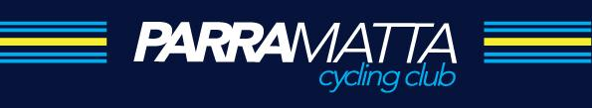

2021 ROAD RACING at OAKVILLE

Racing at Oakville this year is scheduled for the following dates:

Date | Event Scratch/ Handicap
Saturday 10th April | Scratch Race
Saturday 24th April | Scratch Race
Saturday 8nd May | Scratch Race
Saturday 22th May | Scratch Race
Saturday 05th June | Scratch Race
Saturday 19th June | Bent Crank - Handicap
Sunday 20th June | Reserved for LACC Junior tour. (NSW Cycling Event)
Saturday 03rd July | Scratch Race
Saturday 17nd July | Velocipede Cup – Scratch Race
Saturday 31nd July | Scratch Race Featuring Parklife Club Championships
Saturday 14th August | Scratch Race
Saturday 28th August | John Beatty - Handicap
Saturday 11th September | Scratch - Club Championships
Saturday 25th September | LEXUS Scratch Race
Sunday 10th October - Bobbin Head Hill Climb Social Event | (non Racing) Bragging Rights only

- Races will commence at 2:00PM with the start and finish at Oakville Public School on Ogden Road.
- This course utilises only Left turns to ensure safety for both participants and motorists and to minimise any inconvenience.
- The course used for racing is a 7.1km circuit starting and finishing at Oakville Public School in Ogden Rd, Hanckel Road, Old Pitt Town Road, Saunders Road and Smith Road turning back onto Ogden Road.
- All racing will be conducted with the approval of the Hawkesbury City Council, NSW Police Service Hawkesbury Command and sanctioned by the Cycling NSW, AusCycling, and the International Cycling Union.
- Entry fees are $15 for Masters/ Elite/ Junior 19 and $5 for Juniors 17-13 years.

