PCC is going on tour!
9 to 17 October 2021
Bright, Victoria
(A Spring Classic)

Dear Parramatta Cycling Club members & friends,

To break the lockdown blues, we are hitting the road down to Bright Victoria from 9 to 17 October 2021.

Everyone is welcome and it is easy to join in, just book your accommodation in Bright for part or all of the week and join the group for daily rides, sightseeing and lunch/dinner.

Ride options vary from 10km to 110km+, with flat rides and iconic mountain climbs to suit all levels. The organized rides will be no drop social rides with extras for those wanting to push themselves with longer distances and climbs.
It’s a perfect training block if you are building for one of this year’s spring Gran Fondo’s (ie Amy’s Gran Fondo or L’Etape).
On the following page is a sample itinerary of the ride possibilities for the week, which of course will be subject to local conditions and the needs of the group.
Bright is a picturesque town in northeast Victoria on the Ovens River, an area of historic gold fields and famous bushrangers with towns such as Beechworth and Yackandandah although now more well known for wineries, bakeries and other produce.
Nestled in the valley, Bright is surrounded by well-known cycling mountains such as Mt Buffalo, Falls Creek and Mt Hotham, and plenty of easy rides like Wandiligong and Buckland Valley. There’s also mountain bike trails and the long-distance rail trail along the valley.
The town has plenty of accommodation options, several restaurants and many cafés. There are two pubs, as well as the Bright Brewery for post ride refreshments. Also two supermarkets, two bakeries, two bike shops, and an ice cream shop. Everything a cyclist on holiday requires.
Bright will be coming into bloom, as it’s just a week before the Spring Festival, but there’ll be chilly mornings and snow still on the high peaks. The town averages 6-20°C in October, with rain on 8 days.
If you have any queries, please call or email Phil Gates (Club Secretary) +61 418494 972 secretary.parramattacycling@gmail.com
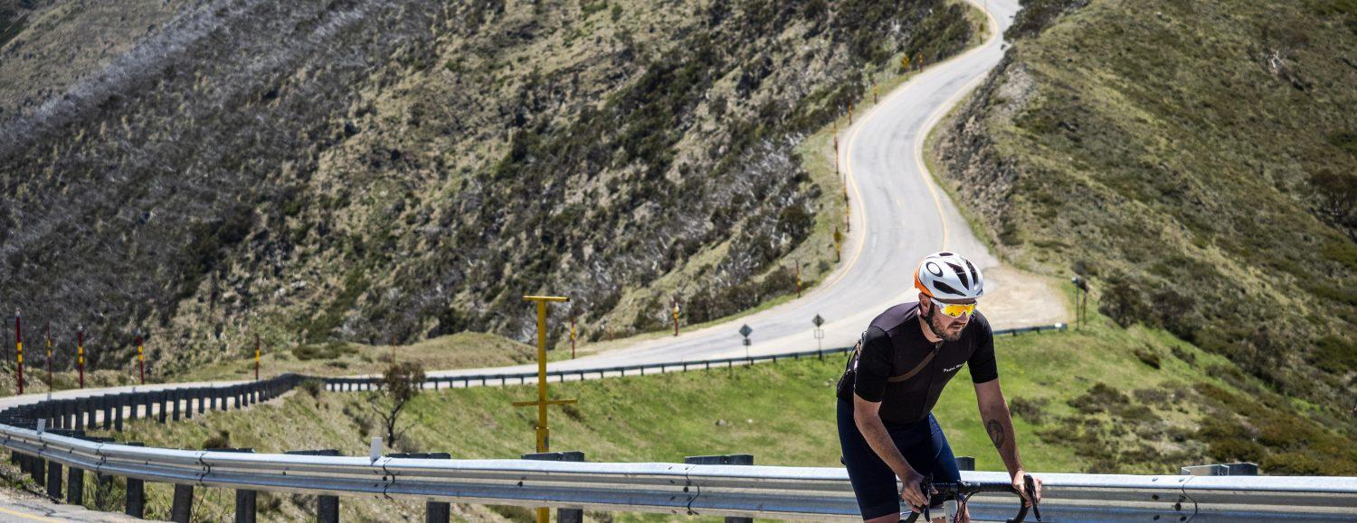

Dates | Indicative Itinerary |  | Terrain | Distance
Saturday 9 October | Ride | For the early arrivals - From Bright, an easy ride to Buckland Valley with coffee at the Rail Trail café on the way back | Easy rolling hills | 40km
 | Lunch | There will be lunch
 | Afternoon | Chilling
 | Dinner | Definitely
Sunday 10 October | Ride | Bright to Tawonga Gap and return. For those who'd like more continue on to Mt Beauty and return up and over the Gap | This is a 8km climb on both sides of "The Gap" 5%-8% gradients. It's a little harder from the Mt Beauty side | 40km/60km
 | Lunch | Bright or the Seasons café in Mt Beauty
 | Afternoon | At leisure ( see below )
 | Dinner | Bright pub, group table.
Monday 11 October |  | Mt Buffalo -From Bright to the Chalet back to Bright. Great climb, not that hard despite the distance with excellent scenery and views. Extras to Lake Canti/Dingo Dell or even to the Horn lookout for 9 more k's | The Classic climb, 20km all up, for a 1040m elevation gain. Fairly consistent gradient 5-6% all the way to the top, then a short downhill before the little climb to the Chalet for an extra 5km. Make sure you walk out to the lookout for the fantastic view. | 70/80km
 | Ride
 | Lunch | Bright
 | Afternoon | Mountain Biking
 | Dinner | Welcome BBQ in Bright
Tuesday 12 October | Ride | Happy Valley in an anti-clockwise direction via Tawonga Gap and Kancoona Gap. There's a lot of Gaps around here? | Over the Tawonga Gap @885m then rolling low hills for 20km, a 4km climb over Kancoona Gap @386m, then a 20km descent and back along the Great Alpine Road for 25km return up the Ovens Valley.  This is a ride of the valleys framed by the ranges. | 110km
 | Lunch | Bright
 | Afternoon | Local sightseeing
 | Dinner | Bright
Wednesday 13 October | Ride | Local ride or ride to Beechworth and meet the rest of the gang | Many ride and drive options to spend the afternoon in Beechworth | Various options up to 76 km
 | Lunch | Beechworth
 | Afternoon | Beechworth
 | Dinner | Bright
Thursday 14 October | Ride | Bright to Falls Creek via Tawonga gap and Mt Beauty. There's a variety of options to choose from to suit the legs you'll have on the day. FYI Mt Beauty is in the bottom of the Valley, go figure. | Leave Bright and climb over Tawonga Gap, appox 7 km climb and descent into Mt Beauty. Then the fun begins, 25km up to the Falls Creek ski resort. There's a few ups and downs along the way but the last 15km are a steady 5-6% gradient through beautiful snowgums to Falls. Option to car shuttle to/from Mt Beauty. | 60km Mt Beauty-Falls Ck, 90km Bright-Falls Ck, or the full monty 120km Bright-Bright
 | Lunch | Seasons café in MtBeauty for morning tea or Lunch
 | Afternoon | Recovery at your leisure
 | Dinner | Bright
Friday 15 October | Ride | Harrietville and up to the Meg if you feel like it | To Harrietville is almost a flat ride (one small hill) 50km return. You can ride up to the Meg towards Mt Hotham if you feel like another 8 km up the hill or continue up to the top of Mt Hotham. | 50km or approx. 60km to the Meg and 102 Km Hotham Rtn.
 | Lunch | Ringer Reef and Mayford Winery
 | Afternoon | Winery tour
 | Dinner | Bright
Saturday 16 October | Ride | Happy Valley in a clockwise direction via Ovens and Kancoona Gap and Tawonga Gap. Despite the route this is a totally different ride to the opposite direction. | Flat for the first 25km then very gradually rises to Kancoona Gap at 3% gradient, then small rolling hills up the Kiewa Valley to the Tawonga Gap climb from where its 20km all downhill to Bright. | 110km
 | Lunch | Bright
 | Afternoon
 | Dinner | Farewell BBQ at a venue to be advised
Sunday 17 October | Ride
 | Lunch | Bright
 | Afternoon
 | Dinner | Bright

